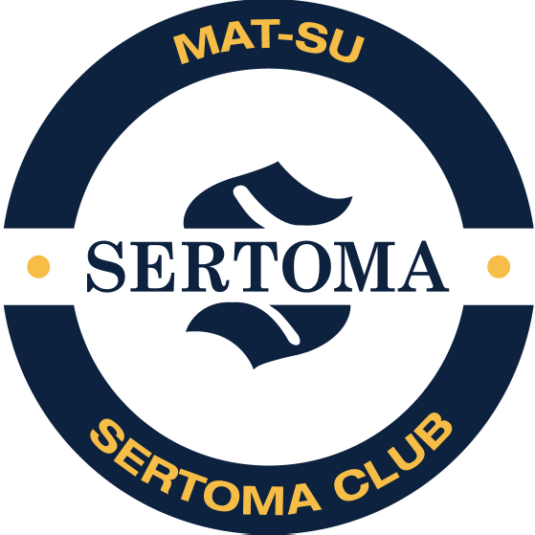

MAT-SU SERTOMA SCHOLARSHIP 2026-27 ACADEMIC SCHOOL YEAR DEADLINE: APRIL 30, 2026
Purpose: A Scholarship for students who are Deaf, Hard of Hearing, or pursuing any Health or Science degree field related to Communication Disorders or bettering the communication with and within the Deaf and HOH community.

Scholarship Program: $1,000 scholarship to cover tuition, fees, books, and supplies. The funds may be used for any academic term during the awarded school year, including summer. This scholarship is made possible by the generous support of the Mat-Su Sertoma Club.

Qualifications: Preference will be given to students who have an evidenced loss of hearing or to students who have an interest in pursuing a career in Speech & Hearing Sciences, or other health- related fields such as Deaf Education, Otolaryngology, Speech Language, Audiology and Sign Language Interpreter. Documentation of a diagnosed hearing loss, if applicable, includes the following: student must have a minimum 40dB bilateral hearing loss as evidenced on an audiogram by a SRT of 40dB or greater in both ears. Student must be a citizen of the United States of America. They must be entering college on a full-time basis or currently attending full-time a college or university in the United States. They must be pursuing or intend to pursue a degree or professional certification in any hearing related or health-field discipline. Must have a minimum un-weighted GPA of 3.2 on a 4.0 scale or 80% in all courses. High
school students entering college will include all coursework for grades 9-11 and first semester of grade 12. For current college freshmen, it will include grades 9-12 and first semester of college. For college students who are sophomores or higher, it will be your college transcript for all college work attempted/completed.

Required Materials: The following items are required to complete the application process. These items must be submitted in a single packet in the order listed (any additional information received separately will be discarded.)

- Application: Must be on Mat-Su Sertoma’s original form and signed.
- Statement of Purpose: Please state how this scholarship will help you achieve your goals (one page maximum).
- Two Letters of Recommendation: Must be from a professional in the Speech/ Hearing Sciences, teacher, or other School official.
- Transcripts: Must be from an officially accredited state, regional, or national institution or School.

Must be an official transcript in sealed envelope showing the name of the school, address, and contact number with a verifiable GPA from coursework listed.

Deadline: All materials must be received by the Mat-Su Sertoma Club by April 30, 2026. If the deadline falls on a weekend, the following Monday will be the deadline. Sertoma will acknowledge receipt of applications by e-mail only; if you want to be notified of receipt include your email on the application. No receipt by phone or fax will be given.

Notification to Recipient(s): Recipient(s) will be notified by June 30, 2024. We only notify recipients, no notification means the student did not receive the scholarship.

Apply to: Mat-Su Sertoma Club, 189 East Nelson Avenue, #235,
Wasilla, AK 99687 ATTN: Academic Committee

OFFICIAL APPLICATION

Student Name

Mailing Address

City Sate Zip

Phone

Email

If applicable: Level of Hearing Threshold (SRT) Left Ear dB Right Ear dB

College/University Information: School the student will be attending or is currently attending on a full time basis leading to a degree or professional certification.

College/University Name

Title of Degree/Certification

Date entered or entering college/university

Anticipated date of graduation from college/university

Total semester credits required for degree/professional certification
Estimated total number of semester credits for the 2026-27 academic year (including summer of 2026)

Estimated cost of tuition/fees, books, supplies for 2026-27 academic
year Cumulative GPA (as described in information sheet) /4.0 scale or %

Please answer the following questions.

COMMUNITY VOLUNTEER ACTIVITIES:

INTERSCHOLASTIC ACTIVITIES:

EXTRACURRICULAR ACTIVITIES (INCLUDE JOBS HELD):

By submitting this application I have given Mat-Su Sertoma Club permission to use my name and relevant information in all forms of publications, including but not limited to, printed and web based.

Printed Name

Signature

Date

Received by

Date

